Your Prayers Don't Matter- satan
July 25th, 2021

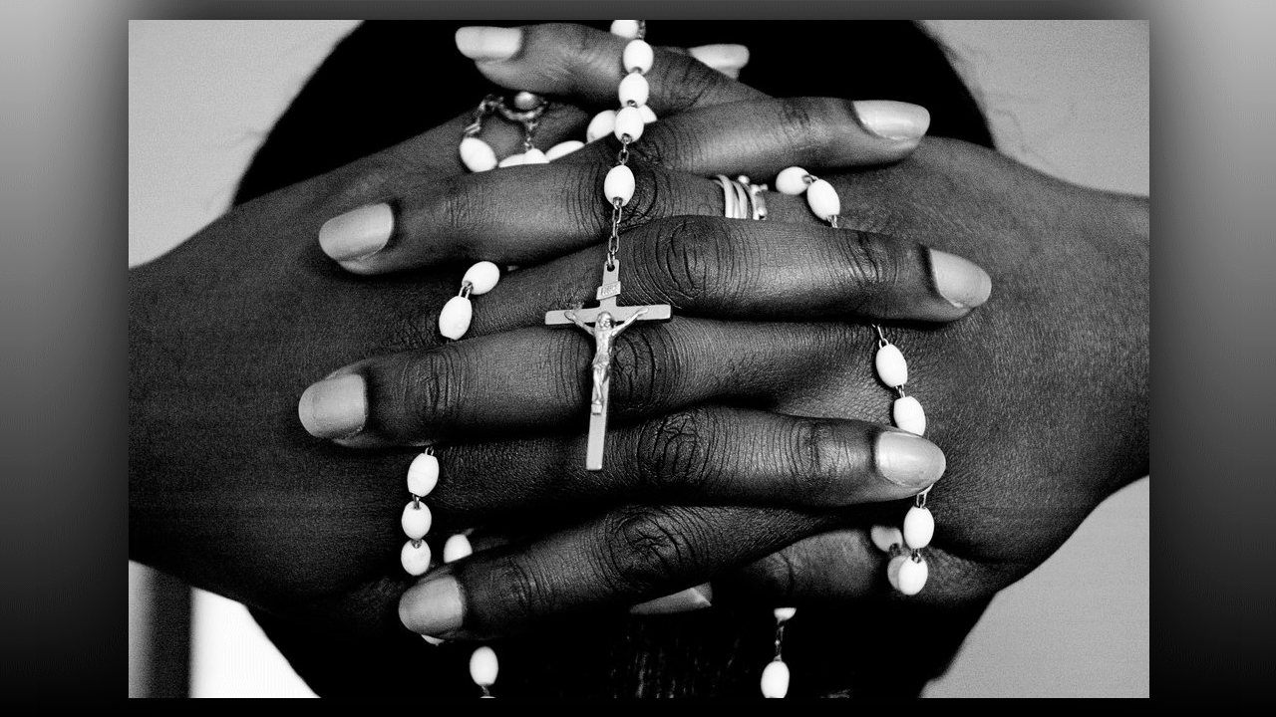
Lord be with you, Heart Dwellers.

Lord Jesus, please crush this myth Satan whispers to us all day and all night that we may have the faith to pray and believe You will move on our prayers. Amen.

Have you ever thought, "My prayers are so weak, I do not think they matter.”? Or this one, "Let the really holy people pray, God does not care about my prayers." Or this one, "God does not hear me because I fell from grace." All of us at one time or another get this lie stuck in our head. I want to tell you; this is a lie from Hell. Here is the message I received yesterday as we were all praying for China, Germany and Nigeria.

It began, "It is good that you are praying for those in extreme distress. This Clare is part of what I was showing you with all the dead bodies covered in sheets. There are yet many more terrible things to befall the earth and many will die and suffer. These prayers may seem very unimportant from your viewpoint but if you were there, you would see how even just one prayer with intention releases graces upon needy souls. Your prayers yesterday for those trapped in the subway saved souls. I know you do not understand it, but the Lord is releasing the graces of conversion to those who know nothing of Him and whose minds have been poisoned by Satan’s lies.

“Grace is indeed a mystery; it flows from one person to the next with imperceptible precision to those souls who are calling out to God. It is even used to stir up the question, “Does God exist?” When they think that, what comes next is, “God if you are real, save me.” That request alone is sufficient to bring one sinner into the kingdom of Heaven, though they have never been taught, there is a mysterious and wonderful exchange between a creature and her creator. This is so sublime it is not easy to explain, but in the spirit, words are not necessary, it is the language of the heart of a soul to the Heart of God. How beautiful this is. Grace in all its glory descends into the hungry heart and they are saved. It is so very simple. Later in Heaven they will learn how things work, but for that one instant all they need to do is cry out to God and say yes.

“This exchange takes place in split seconds, even the repentance and acceptance of forgiveness. So much can be done with so little. These are the mountains of communism that can be moved aside so easily in just a split second, depriving Satan of his long sought-after quarry. Do not underestimate the power of these prayers. Praying Scripture and meditating on the life of my Son, is very powerful. It shows great faith on those who have given their time to gather and intercede for strangers.

“Today it is China, tomorrow it could be America, the prayers will never go forth without accomplishing their end. This is the beauty of the dynamics of grace which your God has so lovingly created for your salvation and the salvation of the truly desperate and needy. So, you see, what you have done tonight has brought forth much fruit. Never will you pray in vain. Never. The Lord sees it all and He rewards. I am your mother of Mercy, spread this message far and wide.”

Well, after she told me that, we were all praying the Rosary in the front room and Ezekiel was in, uh, his room. I went back to talk to Ezekiel, and he said that a soul came to him at the foot of his bed and thanked him for praying for her because she was dying. She was drowning in the flood in China, and she came to thank him for his prayers.

Wow, we just do not know the power of prayer, but I want to encourage you: Pray the simplest prayer that you must pray. Pray the Rosary. Pray with fervor in intercession. If the Lord gives you the burden, pray it with the burden. However, it is, pray, but do not wait for the feelings to come, rather look at the plight of the soul or the plight of a nation and petition God for them. Ask Him to help them. These prayers are effective, we just do not realize how effective they are, nor will we know what we have done until Heaven, then the Lord will show us the fruit of our prayers.

So, do not allow Satan to lie to you, dear ones. Take hold of the rope of faith and allow the Lord to pull you up higher and to answer your prayers. Jesus lives forever to make intercession for the saint, so we should too.

The Lord bless you, dear ones.

And I want to thank those souls who have thought about us and our mission and sent a donation. That was very, very kind of you, and it was really needed. Thank you so much.

God bless you dear Heart Dwellers.

